Hippo Climbdown
In this advanced project, you will make a platform game, in which the sprite can move around, jump and climb, in a way that looks like what happens in the real world, especially including ‘gravity’.
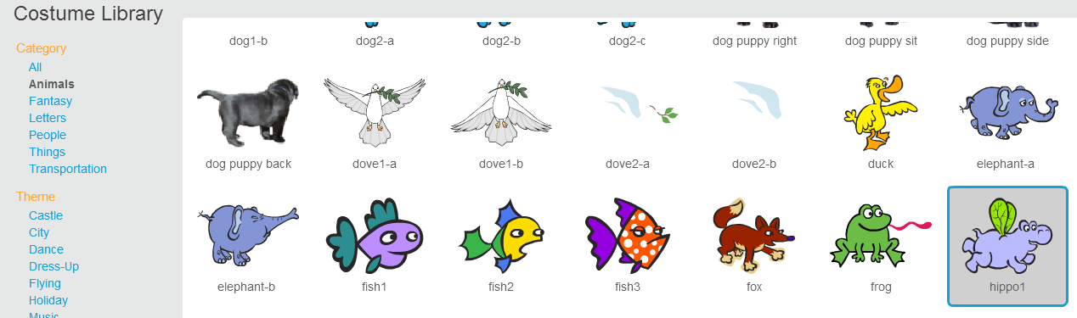
Get a costume from the library: I used a hippo
I made the hippo a bit smaller with this tool:
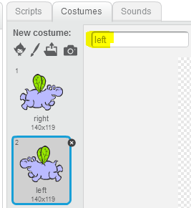

Duplicate the costume into versions pointing right and left

Call the costumes ‘right’ and ‘left’

Paint a new sprite:

This sprite should take up the full size of the stage.
Draw some rectangular ‘steps’ coloured black at various places on the screen, and a long thin rectangle right at the bottom that represents the ground. e.g.

Use this code (‘Script’) to get the new sprite to always be in the right position on the stage:
Set up three ‘Data’ variables like
this:
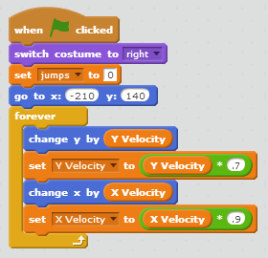
Enter this code for your first sprite (not the steps):
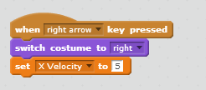
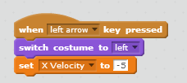
Enter this code so the first sprite can move left and right:

Now play the game.
You should see that your sprite can move when you press the left and right arrow keys.
He slows down a little while after you press the keys – that’s like friction or air resistance in the real world.
He does not fall through the air yet, just sits there: that is not like the real world.
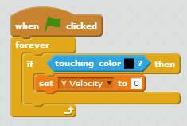
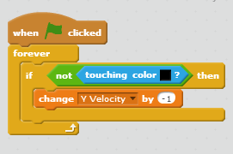
To make him ‘fall’ properly, you need to add gravity to the game:
He doesn’t quite land correctly on each step, until you add:

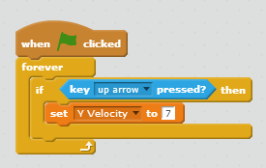
Most video games that look like this involve climbing up as well as climbing down. To enable the hippo to jump, add:
Now you should be able to both descend and ascend using the arrow keys.
Extra:
Change the numbers for jumping, falling down (gravity) and slowing down to see how they affect the game.
Sometimes the top of the hippo sticks to one of the steps above him. How could you fix the game so that doesn’t happen?
Improve the game with your own ideas. Show your finished game to the kids near you and to a mentor. Upload your game to the web (username: coderdojobray; password: brayhead).

