Muffin shower: control game through webcam
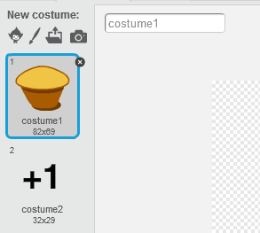
In this advanced project, you will make a game that uses your computer’s webcam to see whether YOU are moving. If you move enough, you get a high score.
Change the costume of a sprite to a muffin.
Make a second costume for that sprite that reads “+1”
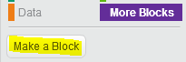
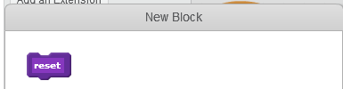
Make your own Scratch ‘block’ to make the muffin appear at random locations on your screen: blocks like this are re-usable and save you duplicating your code. They also make your code look neater and easier to understand.
Call the block ‘reset’:
Then add this code to the block:
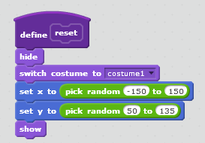
When finished, test the new block by double-clicking it with your left mouse button. You should see a muffin appearing on the stage each time. That’s what this block does.
Add a variable to keep track of the score:

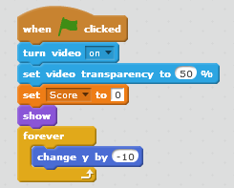
Add this code to turn on your webcam so that you can use your movements (e.g. your head and hands) to interact with the game:
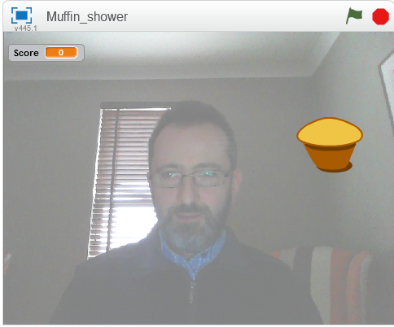
When you press the green flag now, you should see your own reflection on the screen, a bit hazy: (the muffin will fall to the bottom of the screen)

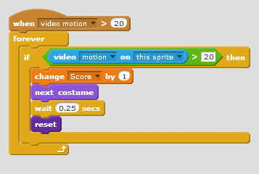
Now add this code to check for motion on your webcam:
When motion occurs (e.g. you move), the game will run ‘reset’ and muffins will fall from the top of the screen.
To get a muffin, point your finger or your hand at it, so that your movement appears on screen, and keep the movement going until you get a score. Then another muffin will appear:
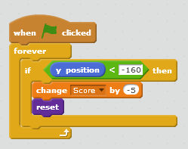
This code penalizes you if any muffins make it to the bottom of the screen; it also makes those ‘lost muffins’ disappear and a new one falls:

Extra:
Experiment with the numbers used to detect motion.
Try standing back from your computer and using motion with your arms to get muffins. Make sure you do this safely and nobody gets hurt!
Now use your own ideas to make the game better.
Show your finished game to the kids near you and to a mentor.
Upload your game to the web (username: coderdojobray; password: brayhead).

