CoderDojo Bray – Advanced - Finish a game with a scrolling background, part 2:
These speech bubbles contain helpful hints for you.

This is where your scrolling game is heading. Make the scrolling background (part 1) first. Then do this part. Apples fall randomly from the sky. Your character needs to collect green apples and avoid red ones. Play it when finished. Then improve it!
We want this sprite to be visible at all times, not hidden by others

Make two additional apple sprites, one green apple and one red. Add some variables: Add more code for the Cat:
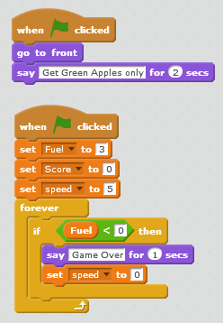
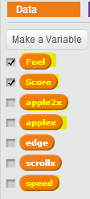
To enter code for a Sprite, make sure you have clicked it here

Small apples work best

It’s game over when the fuel is gone

Fuel keeps the cat moving

Apples fall slowly at the start

Add code for Red Apple: And for Green Apple: (similar, minor changes)
This script runs when it receives a message receives

Apples fall from random x positions

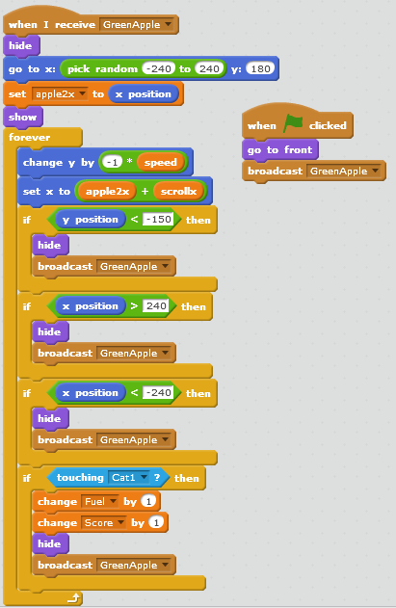
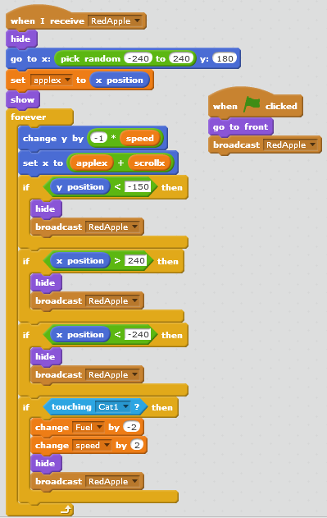
This sends out a message which the other script receives

Apple2x stores the initial x position of the green apple

A hit from a green apple boosts the cat’s fuel and score

Another apple then falls

A hit from a red apple costs the cat fuel and increases the speed of falling apples

This makes the apple fall vertically

Applex stores the initial x position

