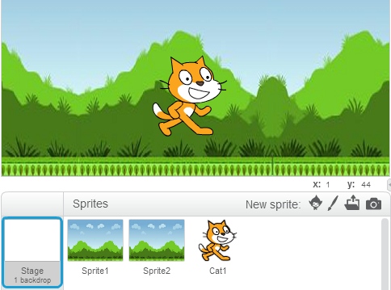
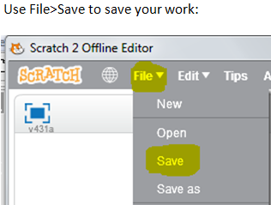
CoderDojo Bray – Advanced: Start making a game with a scrolling background
These speech bubbles contain helpful hints for you.

Both background sprites have width 480

This sets you up to finish a scrolling game in your second session.
Make three sprites as shown: the first two are full-size background pictures that will move. The costumes for these should be the same. You can use Import in the costume painting screen to grab a saved background image that will work for these. (You can create that image using New backdrop for the stage, then saving that to a local file). When you have finished this page, the cat should be able to walk forever in both directions.
Code for the sprites: For Sprite 1:
Puts edge of background image in starting position on stage

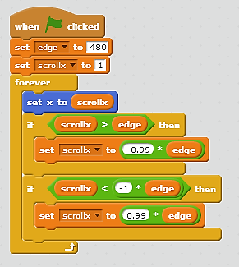

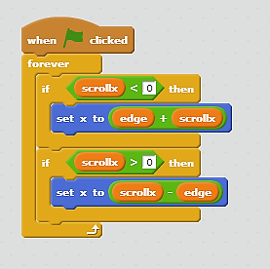
For Sprite 2: For the Cat:
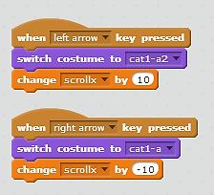

This sprite fills the space left when the other sprite moves

When the cat code changes scrollx, the background sprite moves

When the cat code changes scrollx, the background sprite moves

