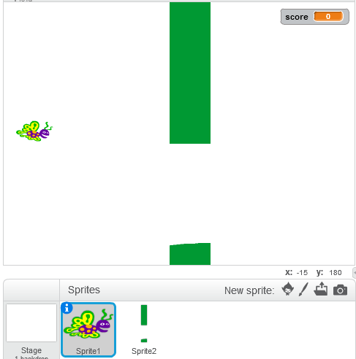
CoderDojo Bray 2015: Flappy Bird in Scratch
These speech bubbles contain helpful hints for you.

Like this

To play the game you use the space bar to make Flappy gain height. You must get him to fly through the gaps in the pillars. The highest score wins.
Create 2 sprites:
- Flappy - a bird with flapping wings. Use the butterfly available in Scratch if you like. Use two costumes for flapping wings.
- Pillar – Draw this and make several copies as costumes (e.g. 5), then use the eraser to make one space in each pillar.
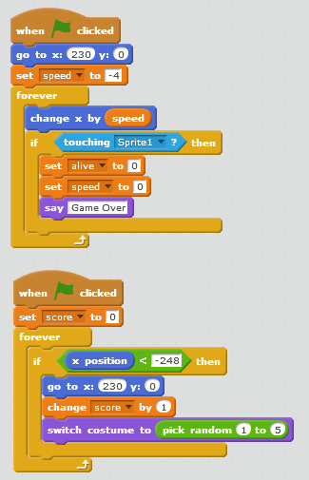
- Enter the code below for Flappy (left) and the pillars (right); add the variables too. Play. Improve the game.
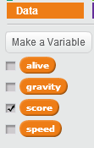
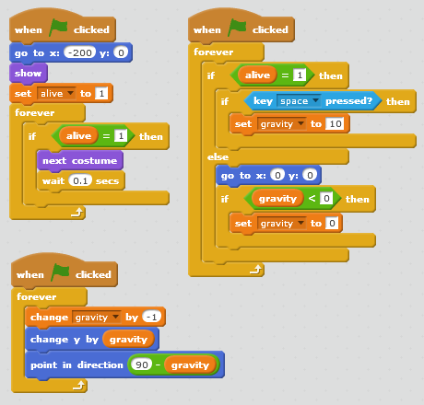
Add these variables:
Changing costumes makes it look like the sprite is flying

Left edge of stage

The next pillar shape is a random choice

Detects collision

Ticking box shows variable on stage

Opposite of hide

