Step by Step Part 2:

Start a new project, in which a cat plays fetch with a ball thrown by a friendly alien.
Use File>New

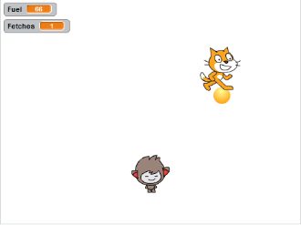
Add new sprites from the Library
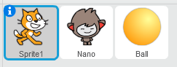
Use this

Get ready to track the score in your game
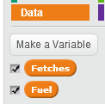
Create two ‘variables’ that will store the score and the amount of fuel remaining before its ‘game over’

Add these code blocks for Nano, so that he can send the command ‘throw ball’
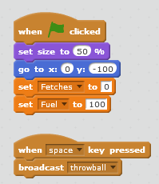
This code listens for the space key to be pressed by you, then sends a command to all sprites

This block gets the game started correctly. Coders call this ‘initializing’. It’s a really good idea

Add these code blocks for Ball, so that it responds to the throw ball command
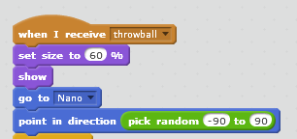
This code makes the direction of the ball a surprise every time – a ‘random number’

This code makes it look like Nano throws the ball

Turn the page over >>>
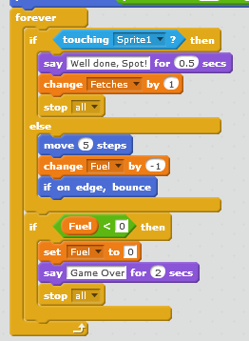
This code checks to see if Sprite1, the cat, has caught the ball. Every ‘fetch’ increases the score

Otherwise, the Cat’s fuel drops. If the ball hits the edge of the screen, it bounces back

If the fuel level gets too low (<0), it’s game over

Add these code blocks for the cat, Sprite1, so that he can fetch the ball by following your mouse pointer
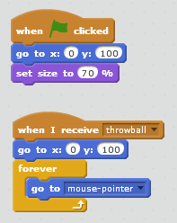
This code makes the cat follow your mouse pointer

This code sets up the cat correctly at the start of the game (‘initializing’)

Play the game and see how many fetches you can get before your fuel runs out.
Press the green flag, then hit the spacebar to throw and move your mouse to fetch.

Save the game
You already know how to do that.

Change the game
Try pulling out some code blocks to see what effect that has on the game.
Change the game to make it more fun to play – e.g. make it harder to score, make the ball move faster and come up with your own ideas.
Move onto another project when you are ready (grab a handout or start your own project).

